**MINI PROJECT REPORT**

**ON**

**“Lifesavers Network: Hope in Drop”**

**SUBMITTED IN PARTIAL FULLFILLMENT OF THE REQUIREMENTS OF DEGREE OF**

**BACHELOR OF ENGINEERING**

**BY**

**MONU VINOD SHAHA SE C 34**

**CHETAN RAMESH ANEKAR SE C 01**

**AMIT SANTOSH NALAWADE SE C 06**

**SUPERVISOR**

**MS. NIKITA SAINDANE**



**DEPARTMENT OF COMPUTER ENGINEERING**

**PILLAI HOC COLLEGE OF ENGINEERING AND TECHNOLOGY, PILLAI’S HOCL EDUCATIONAL CAMPUS, HOCLCOLONY, RASAYANI, TAL: KHALAPUR, DIST RAIGAD 410207 UNIVERSITY OF MUMBAI**

**[2024-25]**

**Mahatma Education Society’s**

**Pillai HOC College of Engineering and Technology, Rasayani-410207**

**2024-25**

**Certificate**

This is to certify that the Mini Project-1A entitled “**Lifesavers Network: Hope in Drop”** is a bonafide work of **Chetan Anekar, Amit Nalawade, Monu Shaha** submitted to the University of Mumbai in partial fulfilment of the requirement for the award of the degree of **“Undergraduate”** in **“Computer Engineering”.**

**Ms. Nikita Saindane**

(Supervisor)

### Ms. Snehal Chitale

(Project Coordinator)



### Dr.Rajashree Gadhave

(Head of Department)

### Dr. J. W. Bakal

(Principal)

# Mini Project-1A Report Approval

This project report entitled **“Lifesavers Network: Hope in Drop”** submitted by **“Chetan Anekar, Amit Nalawade, Monu Shaha”** is approved for the degree of **Bachelor of Engineering in Computer Engineering**.

### Examiners

1.

2.

# Declaration

We declare that this written submission represents our ideas in our own words and where others ideas or words have been included. We have adequately cited and referenced the original sources. We also declare that we have adhered to all principles of academic honesty and integrity and have not misrepresented or fabricated or falsified any idea/data/fact/source in our submission. We understand that any violation of the above will because for disciplinary action by the Institute and can also evoke penal action from the sources which have thus not been properly cited or from whom proper permission has not been taken when needed.

**Chetan Anekar**

**Amit Nalawade**

**Monu Shaha**

**Abstract**

The Lifesavers Network: Hope in Drop project addresses the critical need for blood donations in healthcare systems. This initiative focuses on educating potential donors about the blood donation process, emphasizing essential terms and conditions to ensure informed participation. A significant component of the project is the integration of Body Mass Index (BMI) as a determining factor in blood donation eligibility, helping donors understand how their weight and age influence the volume of blood they can safely donate.

Through informative resources and community outreach, we aim to increase awareness and participation in blood donation, ultimately fostering a supportive network of donors. By promoting understanding and simplifying the donation process, Lifesavers Network aspires to transform the act of giving blood into a widely embraced community effort, ensuring that every drop of blood donated can save lives.

Keywords: ***Blood Donation, BMI Calculation, Donor Eligibility, Lifesaver Network****.*

i

**List of Figures**

|  |  |  |
| --- | --- | --- |
| Figure No | Figure Name | Page  No |
| 4.1 | Home page | 10 |
| 4.2 | Term & Conditions | 11 |
| 4.3 | Steps Of Blood Donation | 12 |
| 4.4 | BMI (Body Mass Index ) | 14 |
| 4.5 | Login & sign up | 15 |
|  |  |  |
|  |  |  |

ii

# TABLE OF CONTENTS

**Content Page No.**

**Abstract i**

**List of figure ii**

1. Introduction 1
2. Requirement Gathering 3
   1. Software and Hardware Requirements
3. Plan of Project 5
   1. Proposed System Architecture
   2. Methodology
4. Result analysis 11
   1. Results
5. Conclusion 17
6. References 19

# Chapter 1

**Introduction**

1

# Introduction

In today's world, where medical emergencies can arise at any moment, the need for blood donation has never been more critical. The Lifesavers Network: Hope in Drop project aims to bridge the gap between donors and recipients by promoting awareness and simplifying the blood donation process.

This project will cover essential aspects of blood donation, including necessary terms and conditions, to ensure that potential donors are well-informed. A key focus of our initiative is the Body Mass Index (BMI), a vital metric that helps determine the appropriate volume of blood a donor can safely contribute based on their weight and age. By educating individuals on these factors, we hope to encourage more people to participate in this life- saving act, fostering a community of compassion and support.

Join us as we explore the significance of blood donation and empower individuals to become lifesavers in their own right. Together, we can create a network of hope, ensuring that every drop counts.

2

# Chapter 2 Requirement Gathering

3

# Software and Hardware Requirements

Here we will discuss everything we will need in order to execute. Below we list the necessary hardware and software requirements.

## Software Requirements:

* + **Programming Languages:** HTML, CSS, JavaScript.
  + **Operating System:** Windows 7 or above.
  + **Editor-:**Notepad / VS Code.
  + **Database:** MySQL.

## Hardware Requirements:

* + **Processor:** Intel i3 or above
  + **RAM:** Minimum 4 GB
  + **Storage:** Minimum 1 GB or above for server setup
  + **Device:** Laptop (HP Victus)

4\

**Chapter 3**

**Plan of Project**

5

# Proposed System Architecture

The system architecture for **t**he **“ Lifesavers Network: Hope in Drop”** is designed with a clear separation between the front-end and back-end to ensure a scalable, efficient, and secure web application. At the front-end, the user interface (UI) is built using a combination of **HTML**, **CSS**. HTML provides the basic structure of the website, ensuring accessibility and compatibility across various browsers and devices. CSS defines the presentation and allows for rapid styling with a focus on responsiveness and design consistency. This ensures a modern, user-friendly, and visually appealing interface that is intuitive for both novice and experienced users. The back end is powered by **JavaScript** which handles server-side logic such as user authentication, product catalog management, and transaction processing.

6

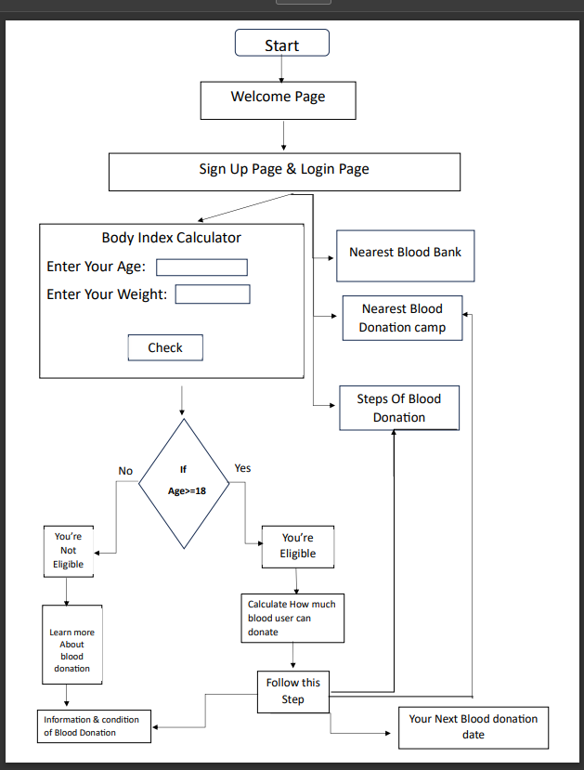

8

# Methodology

The development of the "Lifesavers Network: Hope in Drop" project follows a structured methodology to ensure effective planning, implementation, and evaluation. The approach consists of several key phases:

### Research and Analysis

* + - * **Literature Review:** Conduct a review of existing blood donation platforms and best practices to identify gaps and opportunities for improvement.
      * **User Needs Assessment**: Gather insights from potential users, including donors and recipients, through surveys and interviews to understand their needs and expectations.

### System Design

**Architecture Planning**: Design the system architecture, detailing the front-end and back-end components, data flow, and user interactions.

**Wireframing**: Create wireframes and prototypes of the user interface to visualize the layout and functionality before development

### Development

* **Front-End Development**: Build the user interface using HTML and CSS, focusing on responsive design and user experience.

8

* **Back-End Development**: Implement server-side logic using JavaScript, ensuring user authentication, data management, and transaction processing functionalities are securely integrated.

### Testing

* **Unit Testing**: Conduct unit tests on individual components to ensure they function as intended.
* **Integration Testing**: Test the interaction between front-end and back-end components to verify data flow and user interactions.
* **User Acceptance Testing**: Gather feedback from real users to identify any issues or areas for improvement before the official launch.

### Deployment

* + **Hosting and Launch**: Deploy the application on a reliable hosting platform, making it accessible to users.
  + **Documentation**: Prepare user manuals and technical documentation to assist users and future developers.

### Maintenance and Evaluation

* + **Monitoring**: Continuously monitor system performance and user feedback to identify and resolve any issues promptly.
  + **Updates and Improvements**: Regularly update the platform based on user feedback and technological advancements to enhance functionality and user experience.

By following this methodology, the Lifesavers Network aims to create a robust, user- friendly platform that effectively facilitates blood donation, encourages community participation, and ultimately saves lives.

9

# Chapter 4

**Result**

10

Figure 4.1 Home Page

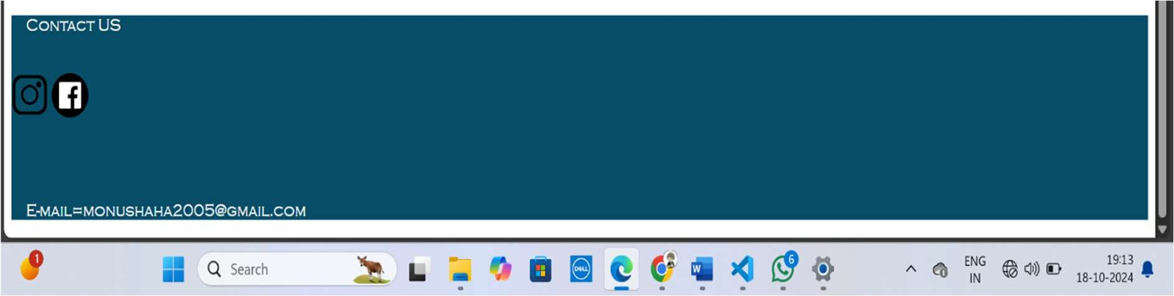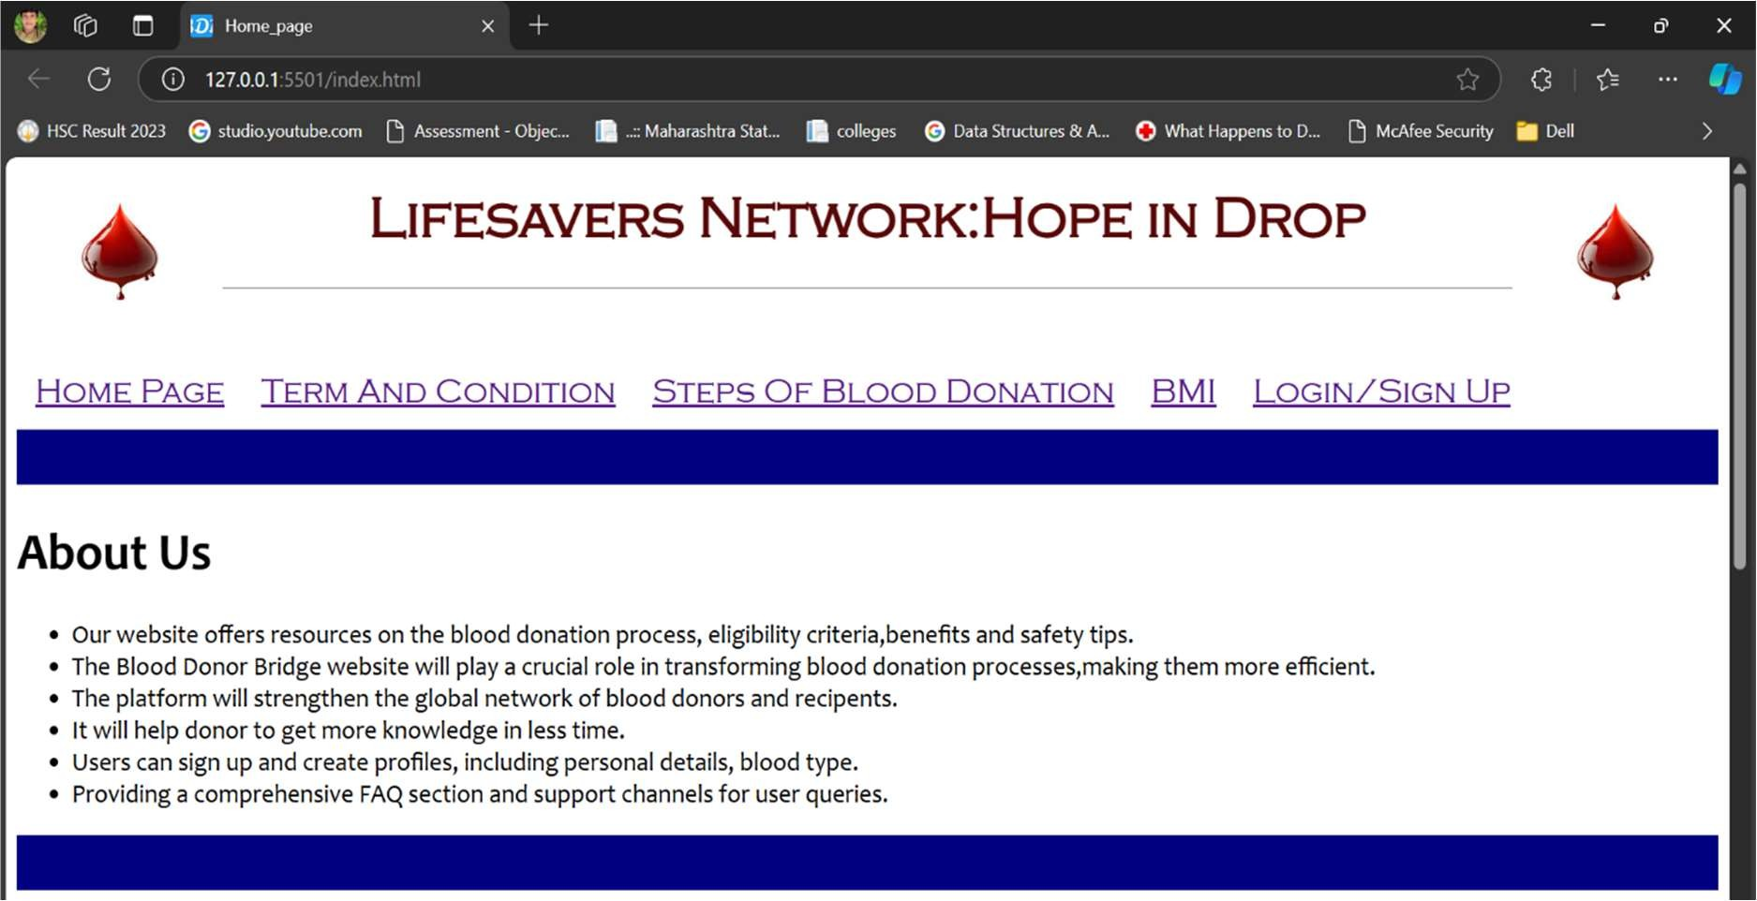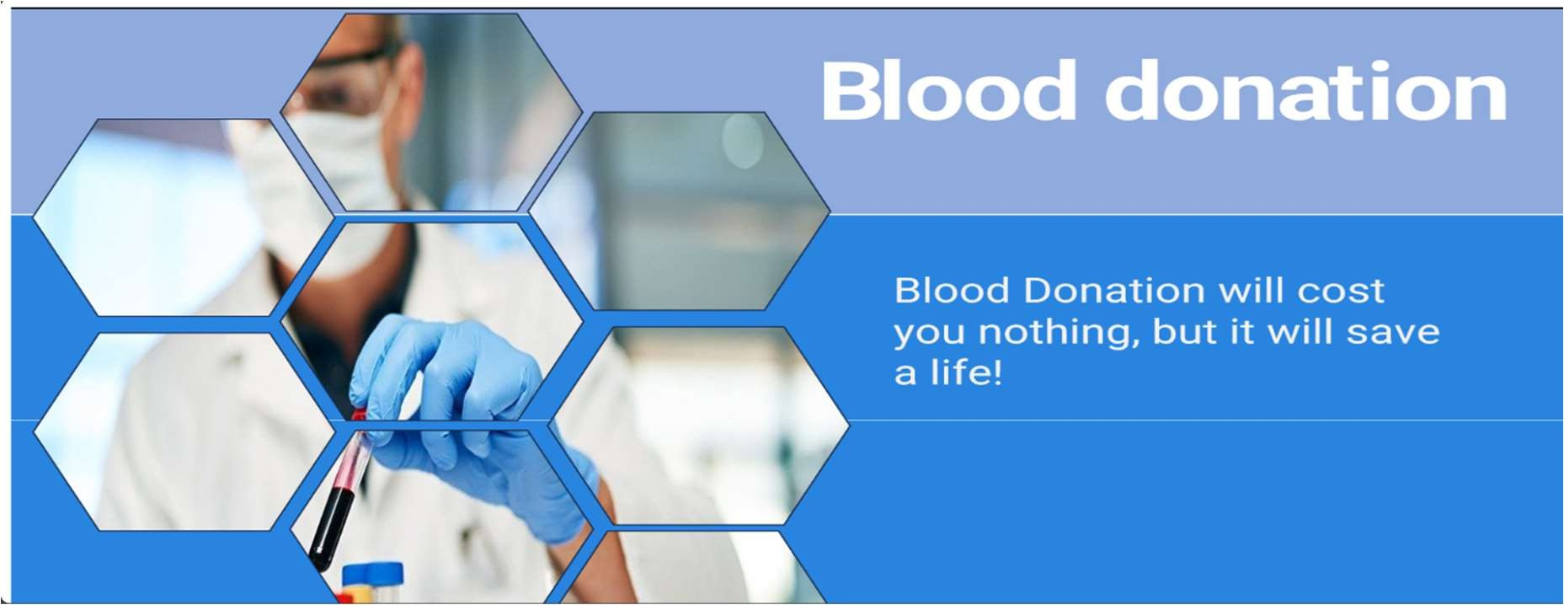

**Figure 4.1 Home Page**

The main Home page is the first page user see when they visit website, providing access to all

the site’s modules

11

Figure 4.2 Term & Condition

The Term & Condition page is the Second page user see when they visit website, providing access to all

Term & Conditions.

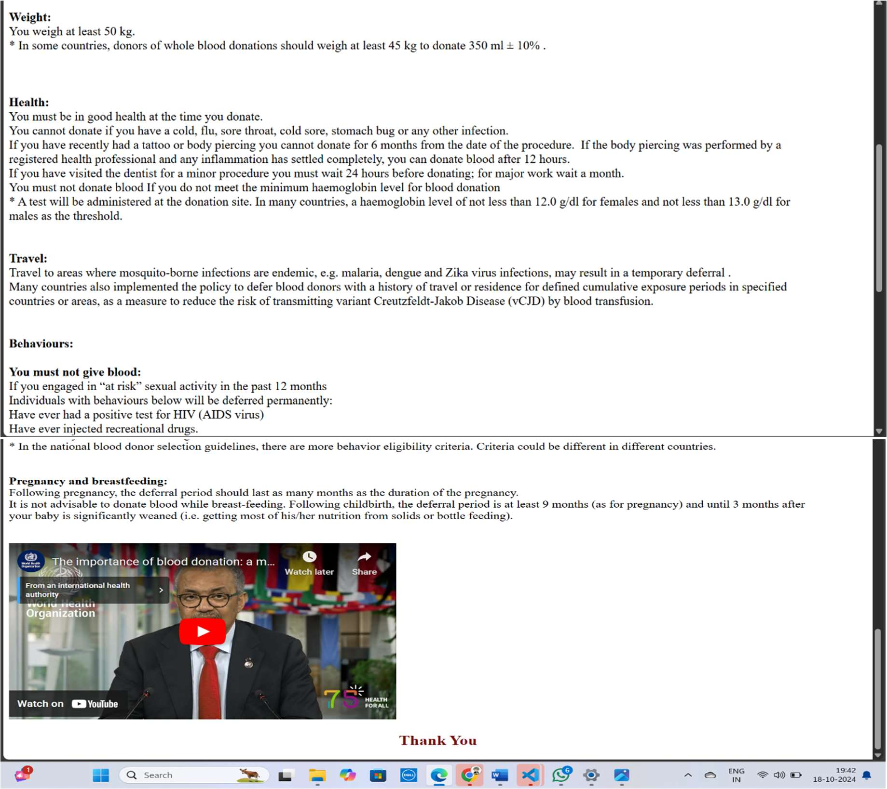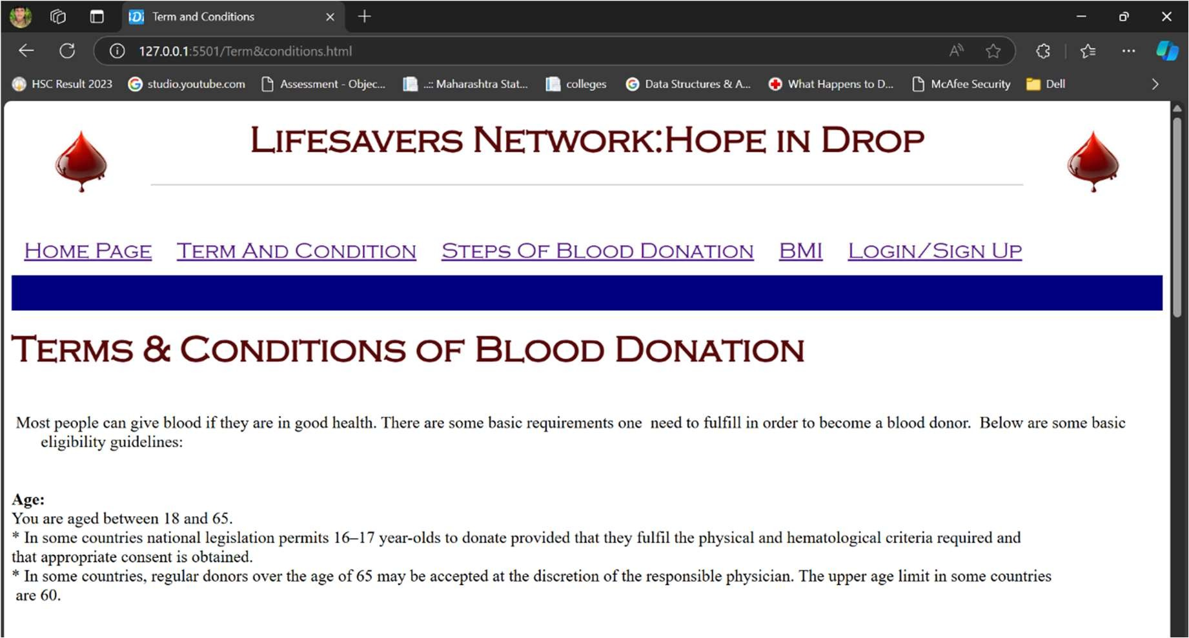

12

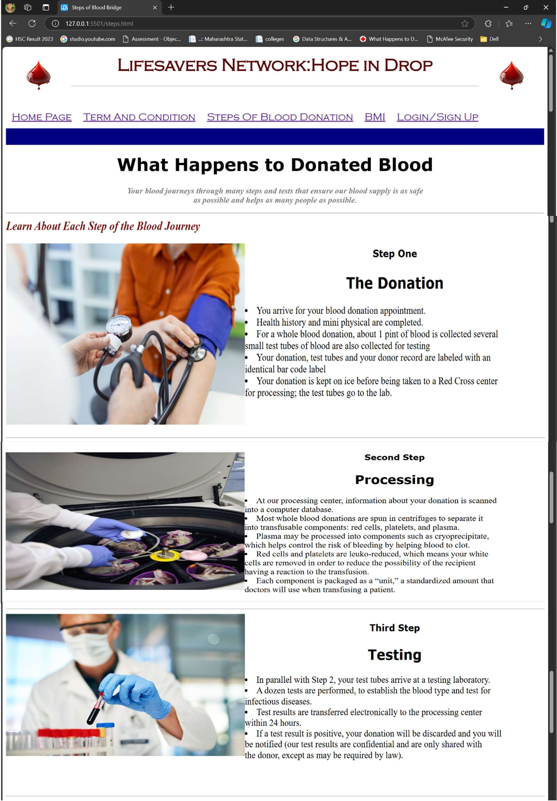

Figure 4.3 Steps Of Blood Donation

13

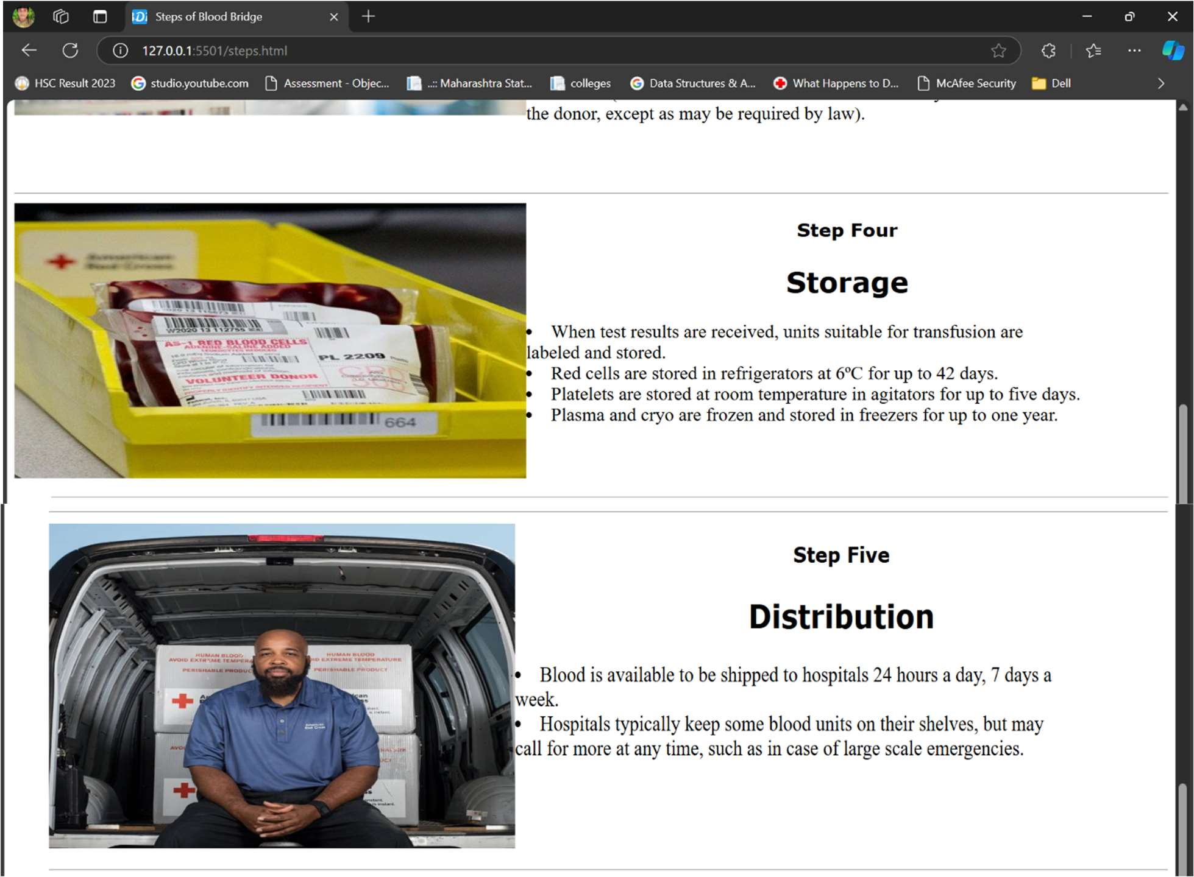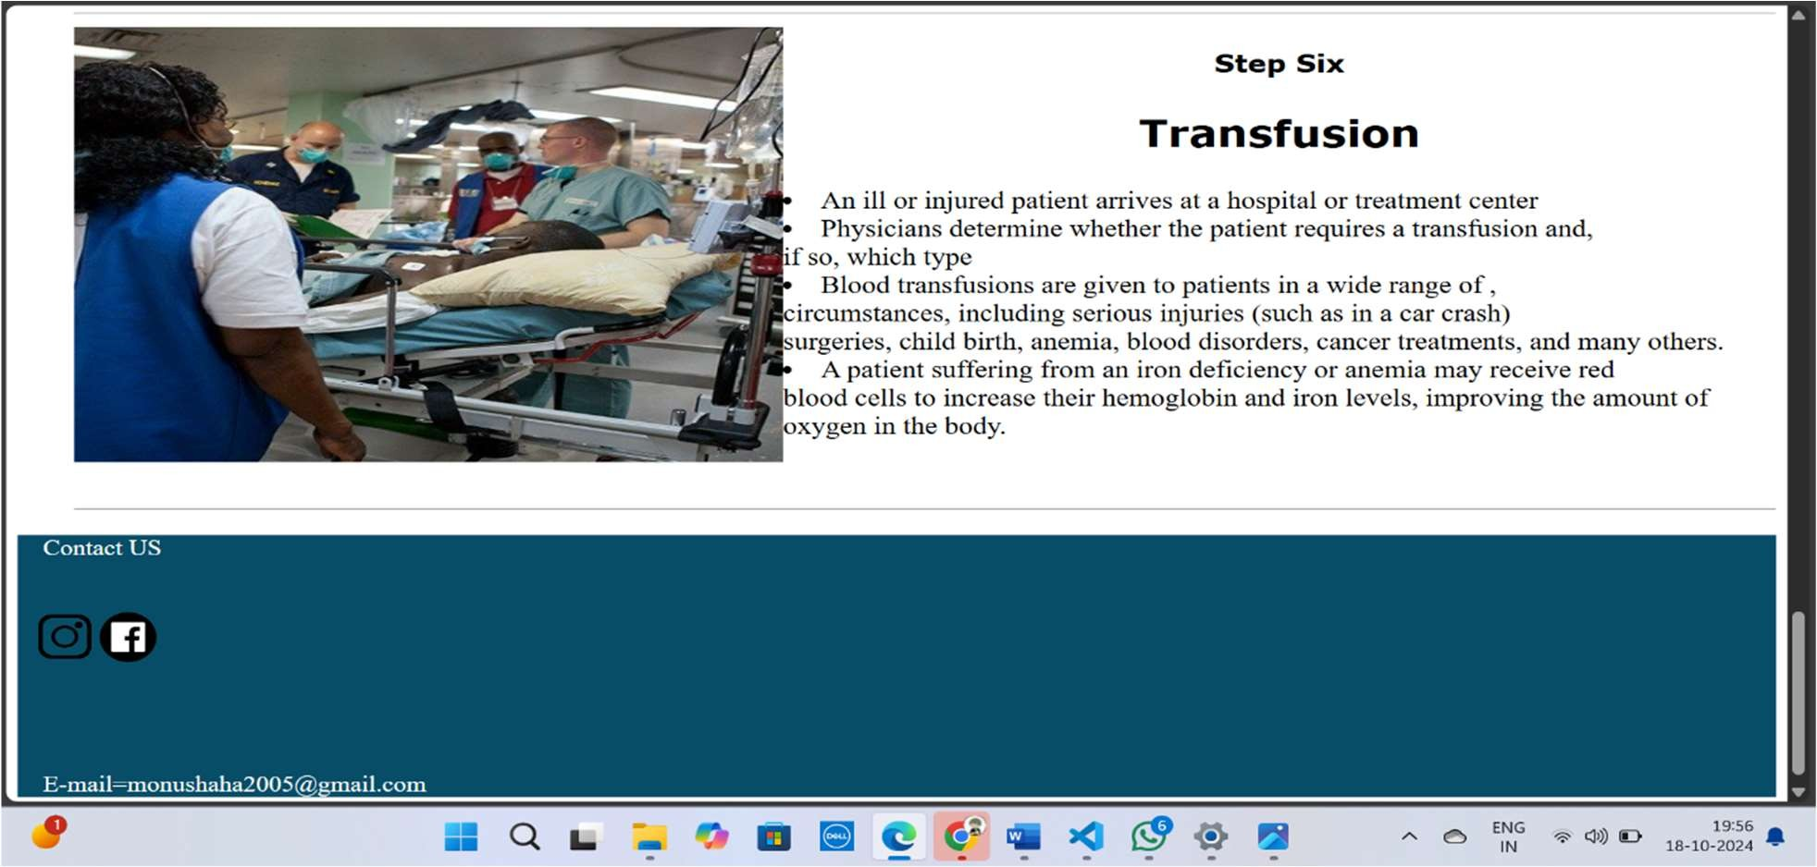

14

The Steps of blood donatin is the Third page user see when they visit website, providing access to all information about of blood donation

Term & Conditions.

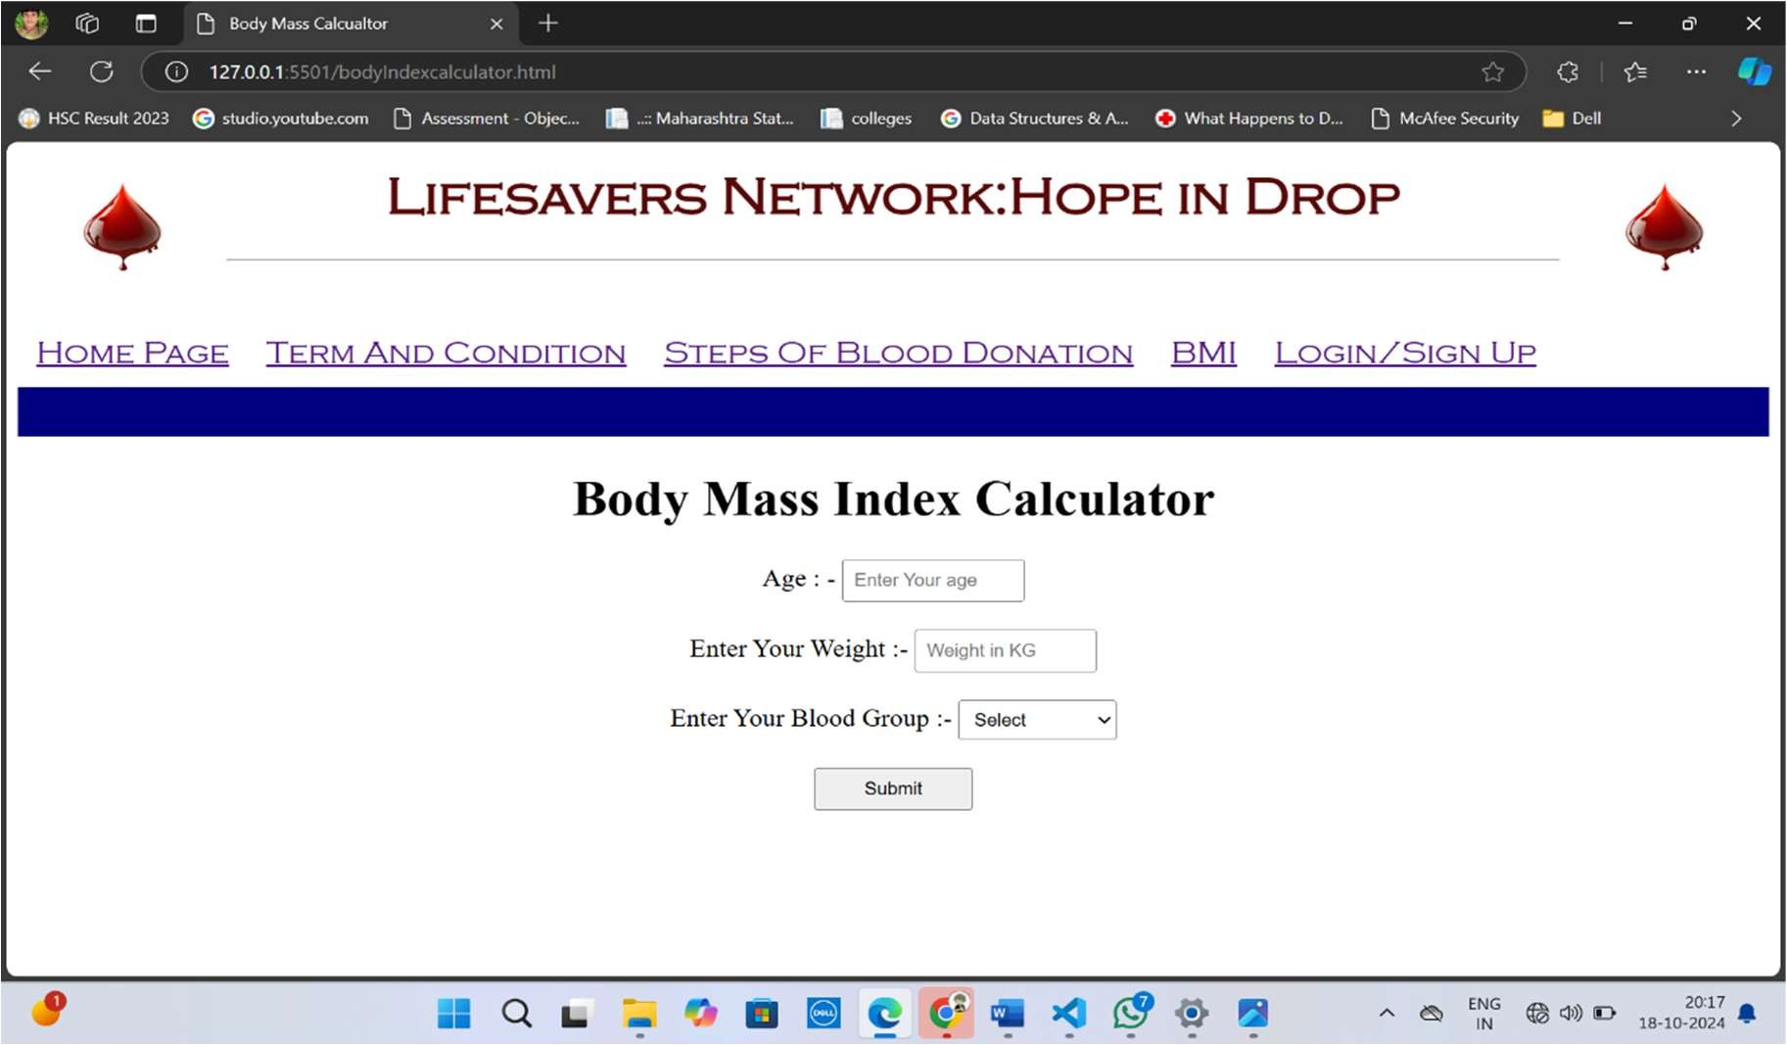

Figure 4.4.1 BMI (Body Mass Index ) Input

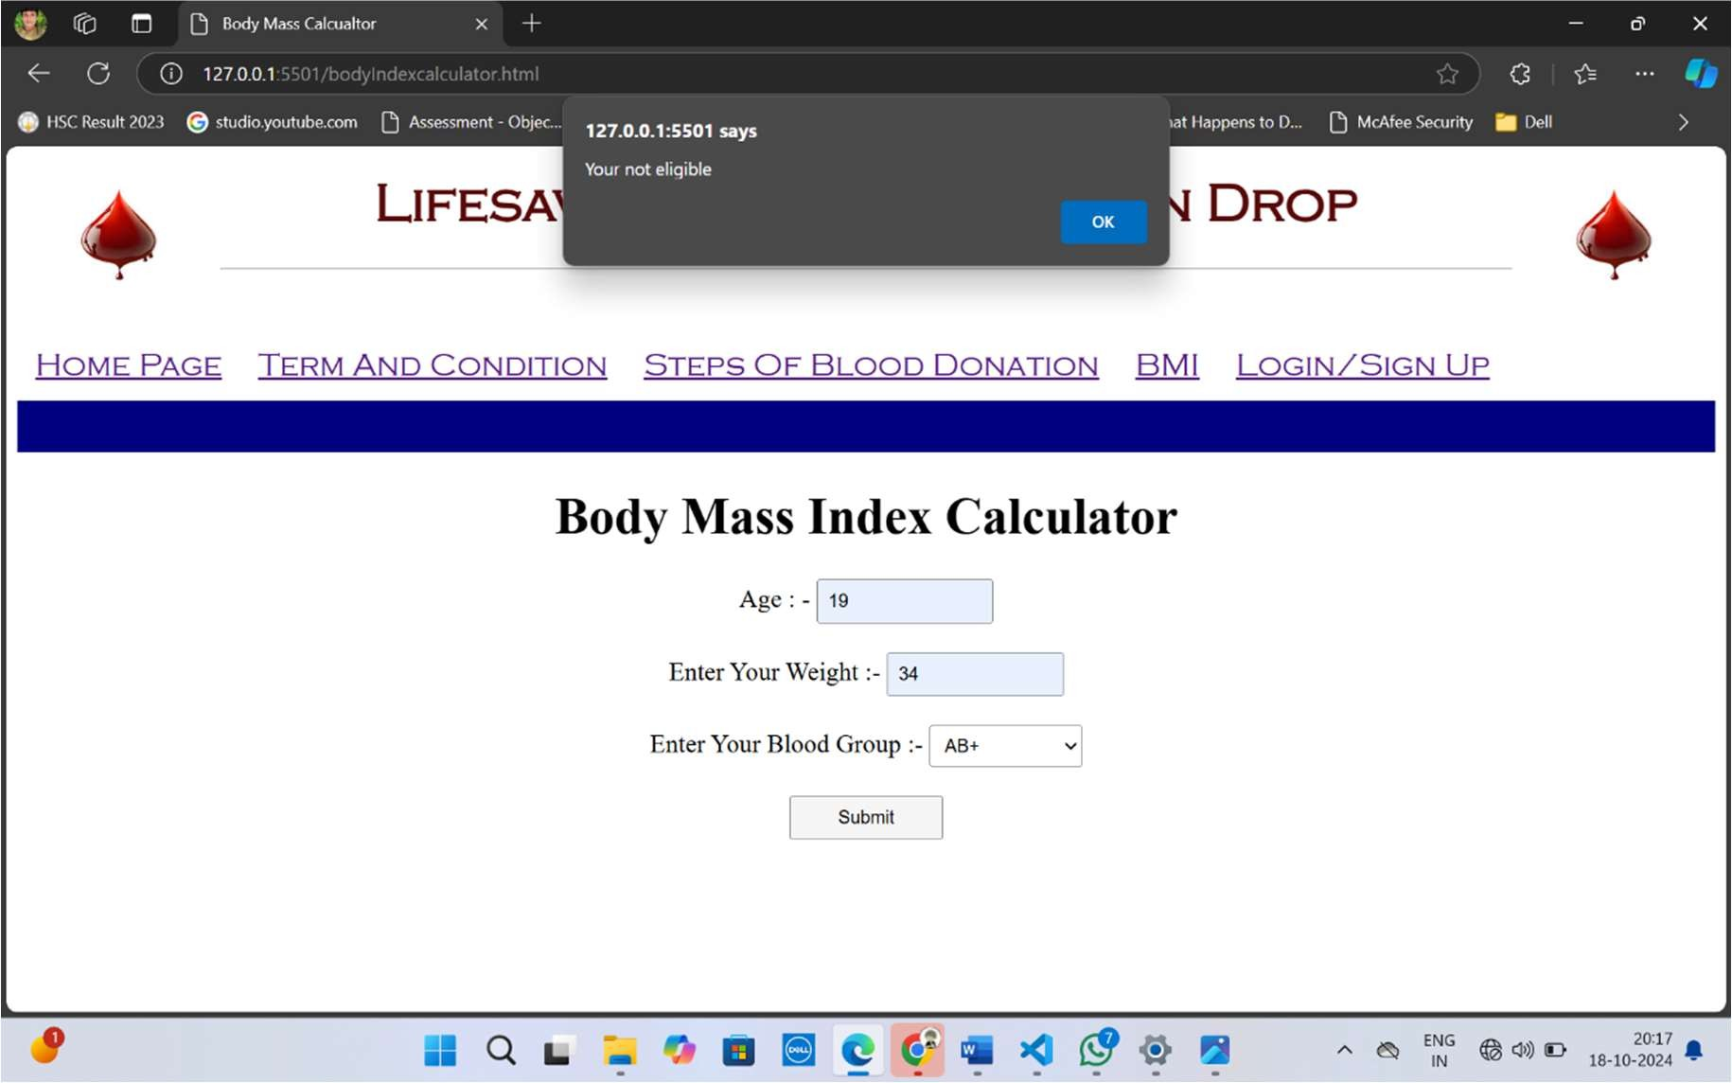

15

Figure 4.4.1 BMI (Body Mass Index ) Output

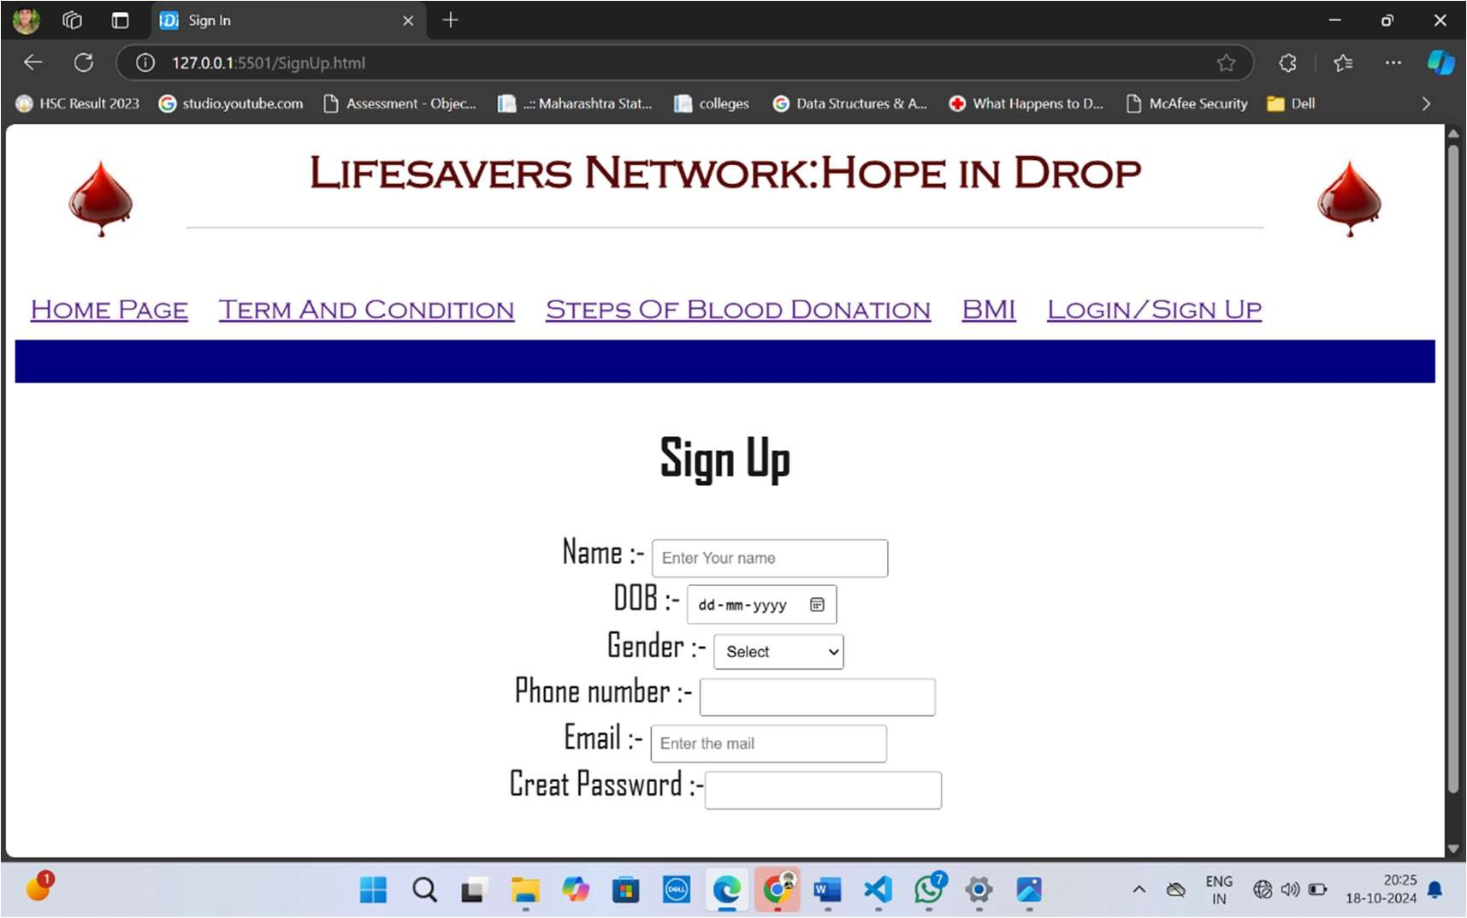

Figure 4.5.1 Login Page

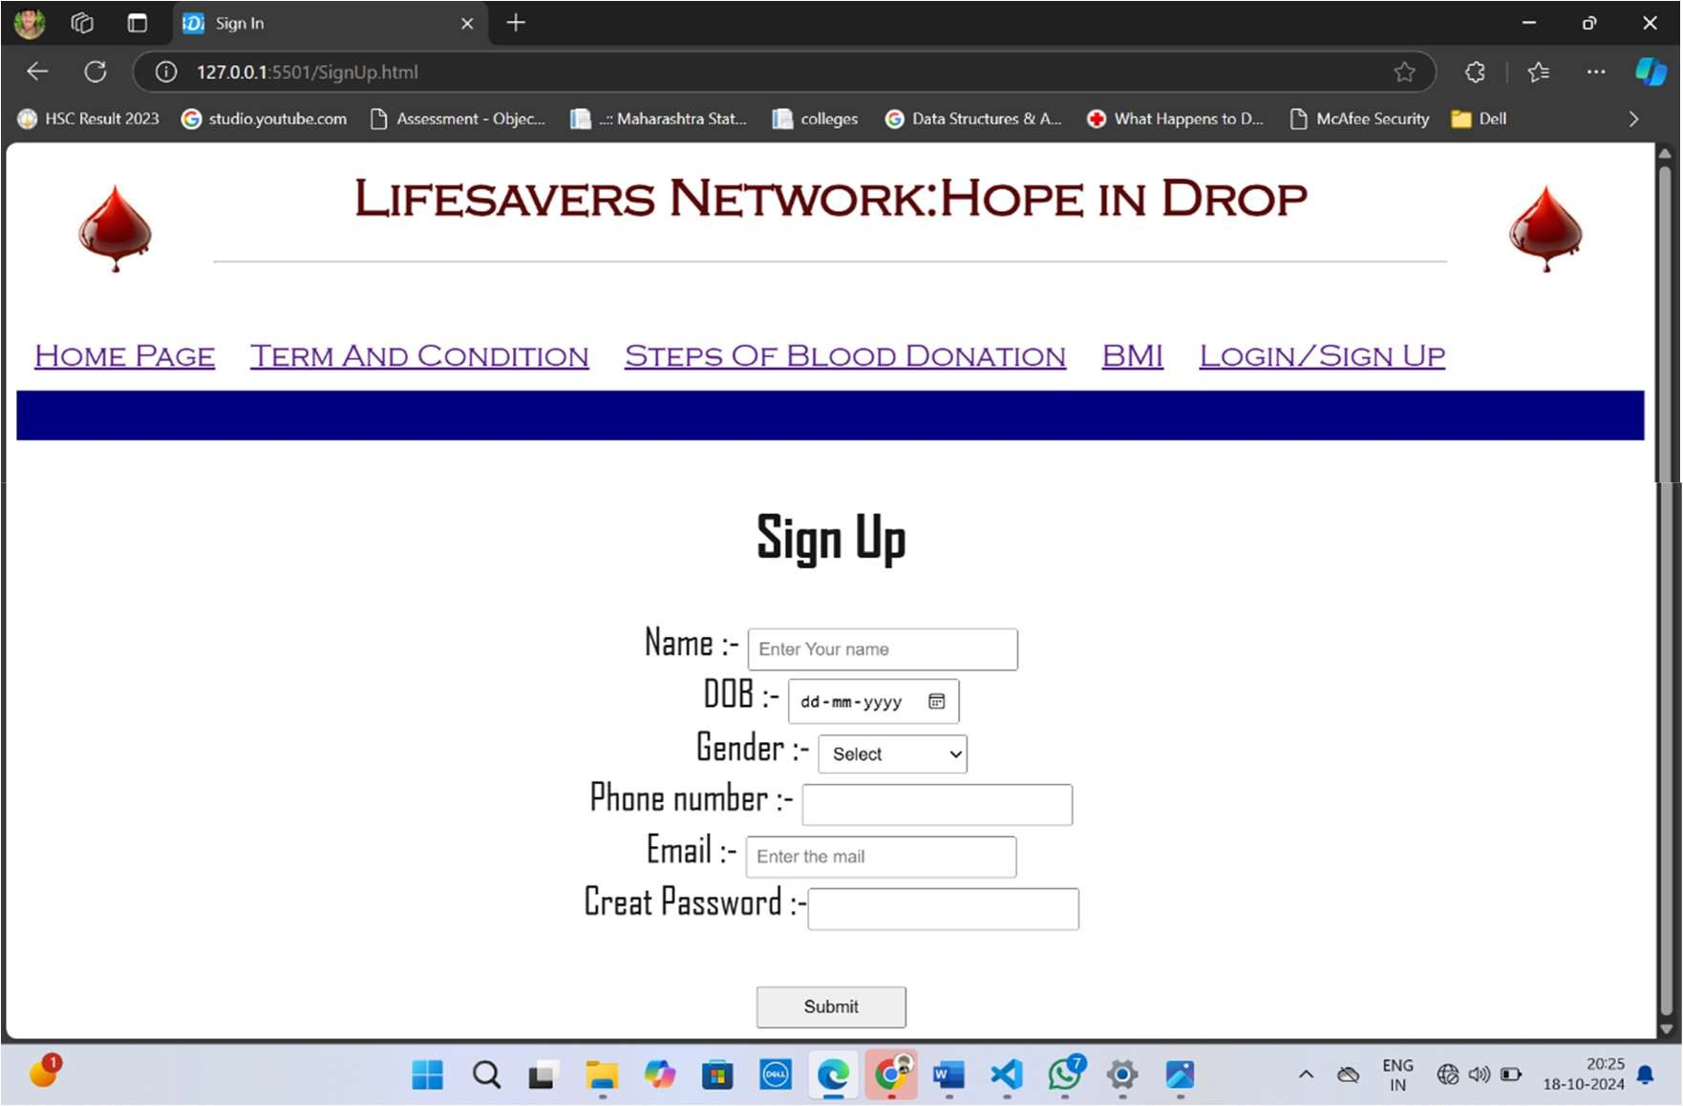

16

Figure 4.5.2 Sign Up Page

**Chapter 5 Conclusion**

17

**Conclusion**

The "Lifesavers Network: Hope in Drop" project embodies a vital initiative to enhance blood donation awareness and participation within communities. By integrating a well- defined system architecture, comprehensive methodology, and a focus on user experience, we aim to create an efficient and secure platform that connects donors and recipients effectively.

Through education on the blood donation process, including the significance of Body Mass Index (BMI) in determining donation eligibility, we empower individuals to make informed decisions about their contributions. The project not only seeks to increase the number of registered donors but also fosters a sense of community and shared responsibility in saving lives.

As we move forward, ongoing monitoring, user feedback, and regular updates will ensure the platform remains relevant and responsive to the needs of its users. Ultimately, the Lifesavers Network aspires to cultivate a culture of compassion and support, making every drop of blood count and providing hope to those in need. Together, we can create a healthierfuture, onedonation at a time.

18

**References**

* + - 1. **World Health Organization (WHO)**. (2019). *Blood Transfusion Safety*.
      2. **American Red Cross**. (2019). *The Importance of Blood Donation*. Retrieved from American Red Cross
      3. **Centers for Disease Control and Prevention (CDC)**. (2020). *Blood Donation: What You Need to Know*. Retrieved from
      4. **National Institutes of Health (NIH)**. (2020). *Understanding Body Mass Index (BMI)*.
      5. **Bhandari, S. & Sharma, S.** (2022). *A Study on Factors Influencing Blood Donation in Urban Areas*. *Journal of Community Health*, 45(1), 50-56.
      6. **Kumar, R., & Sharma, A.** (2023). *Innovations in Blood Donation Awareness Programs*. *Health Promotion International*, 36(3), 567-578.
      7. **Singh, P. et al.** (2023). *The Role of Technology in Promoting Blood Donation: A Review*. *International Journal of Blood Transfusion and Immunohematology*, 9(2), 15-22.